ReadSpeaker webReader Player Features
The ReadSpeaker webReader player has many features that you can use to customize how you access reading material in the Learning Management System. Read below to learn more.

Settings

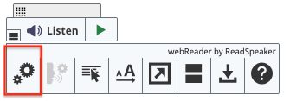
The first button, two gears, will allow you to adjust your settings. By clicking on it, you can turn text highlighting on or off, choose if and how you want text highlighted, select highlighting colors, turn automatic scrolling on or off, or restore the default settings.

Read on Hover
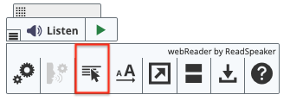
Click the third button, a pointer arrow hovering over lines, to turn on or off the read-on-hover feature. When turned on, a green dot will appear on the button, and webReader will read paragraphs when your cursor overs them instead of selecting text and pressing Listen.

Enlarge Text
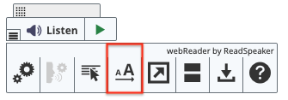
The fourth button, a small and large letter A, allows you to increase or decrease the font size. When the feature is turned on, a green dot will appear on the button, and webReader will show the text at the bottom of the page. The font will be larger and highlighted as read.

Text Mode
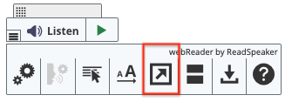
Click the fifth icon, an arrow inside a box, to enter text mode, which opens a pop-up window displaying the text and any images that have supporting text. From this window, you can also adjust font size, reading speed, and window size to help you focus.

Page Mask
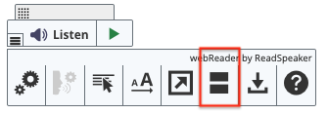
The sixth button, two thick bars, will turn on the page mask. This feature dims the screen except for the area surrounding your cursor (or finger on a touch screen). The page mask allows you to zero in and focus. You can click the + to increase the visible area or the - to decrease it. Click the X or Esc key to close the page mask. You can also use arrow keys to move the mask up or down. To use keyboard navigation while in page mask mode, hit the spacebar, which will display a small keyboard just above the mask to show it is active. You can then use shift + arrow keys to move the mask faster.

Download mp3
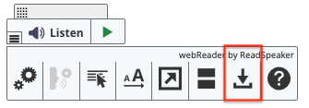
Click the seventh button, a downward arrow, to download an mp3 file with an audio version of the content or selected text.

Help
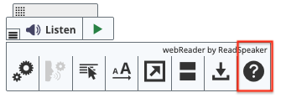
The final button, a question mark, will open a pop-up window with more information on using ReadSpeaker. You can also visit the ReadSpeaker website to learn more.

